AIM:

- To investigate the principal stresses σ_{a} and σ_{b} at any given point of a structural element or machine component when it is in a state of plane stress.

- To evaluate the two different yield criteria ( Tresca and Von Mises ) for ductile materials under plane stresses.

INTRODUCTION:
Structural elements and machine components made of a ductile material arc usually designed so that the material will not yield under the expected loading conditions. When the element or component is under uniaxial stress (Fig. 1), the value of the normal stress σ_{x}, which will cause the material to yield, may be obtained readily from a tensile test conducted on a specimen of the same material, since the test specimen and the structural element or machine component are in the same state of stress. Thus, regardless of the actual mechanism which causes the material to yield, we may state that the element or component will be safe as long as σ_{x}<σ_{Y}, where σ_{Y} is the yield strength of the test specimen.
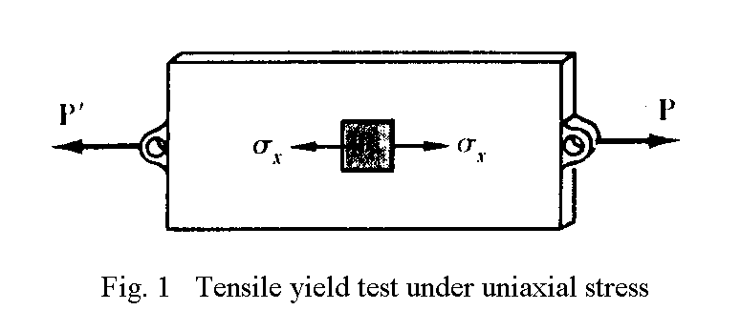

On the other hand, when a structural element or machine component is in a state of plane stress (Fig. 2a), the principal stresses σ_{a} and σ_{b} at any given point can be determined (Fig. 2b). The material may then be regarded as being in a state of biaxial stress at that point. Since this state is different from the state of uniaxial stress found in a specimen subjected to a tensile test, it is clearly not possible to predict directly from such a test whether or not the structural element or machine component under investigation will fail. Some criteria regarding the actual mechanism of failure of the material must be established.
Maximum-Shearing-Stress Criterion.
According to this criterion, a given structural component is safe as long as the maximum value τ_{max} of the shearing stress in that component remains smaller than the corresponding value of the shearing stress in a tensile-test specimen of the same material as the specimen starts to yield.
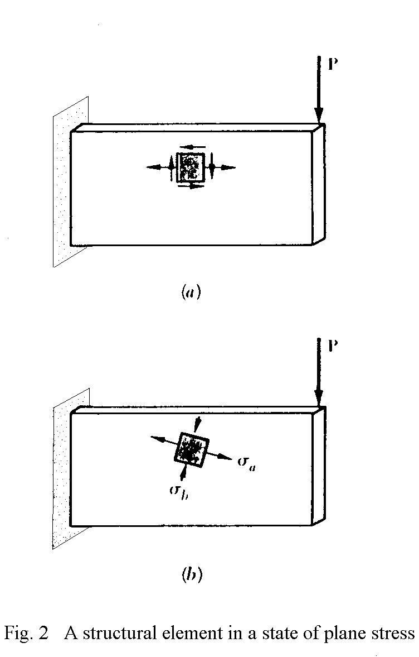
The maximum value of the shearing stress under a centric axial load is equal to half the value of the corresponding normal axial stress, hence the maximum shearing stress in a tensile-test specimen is ½σ_{Y} as the specimen starts to yield. On the other hand, for plane stress, the maximum value τ_{max} of the shearing stress is equal to ½|σ_{max}| if the principal stresses are either both positive or both negative, and to ½|σ_{max} – σ_{min}| if the maximum stress is positive and the minimum stress negative. Thus, if the principal stresses σ_{a} and σ_{b} have the same sign, the maximum-shearing-stress criterion gives

|σ_{a}| < σ_{Y} |σ_{b}| < σ_{Y}

If the principal stresses σ_{a} and σ_{b} have opposite signs, the maximum-shearing-stress criterion yields
|σ_{a} – σ_{b}| < σ_{Y}
The relations obtained have been represented graphically in Fig. 3. Any given state of stress will be represented in that figure by a point of coordinates σ_{a} and σ_{b}, where σ_{a} and σ_{b} are the two principal stresses. If this point falls within the area shown in the figure, the structural component is safe. If it falls outside this area, the component will fail as a result of yield in the material. The hexagon associated with the initiation of yield in the material is known as Tresca's hexagon.
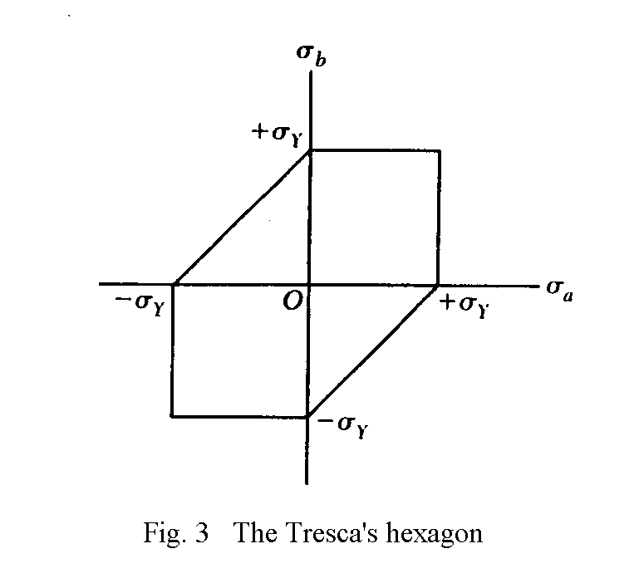

Maxirnum-Distortion-Enoryy Criterion
According to this criterion, known as the von Mises criterion, a given structural component is safe as long as the maximum value of the distortion energy per unit volume in that material remains smaller than (u_{d})_{Y}, the distortion energy per unit volume required to cause yield in a tensile-test specimen of the same material. If the distortion energy per unit volume in an isotropic material under plane stress is u_{d}, the maximum-distortion-energy criterion indicates that the structural component is safe as long as u_{d} < (u_{d})_{Y}, i.e., as long as the point of coordinates σ_{a} and σ_{b} falls within the area shown in Fig. 4. This area is bounded by the ellipse of equation
σ_{a}² – σ_{a}σ_{b} + σ_{b}² = σ_{Y}²
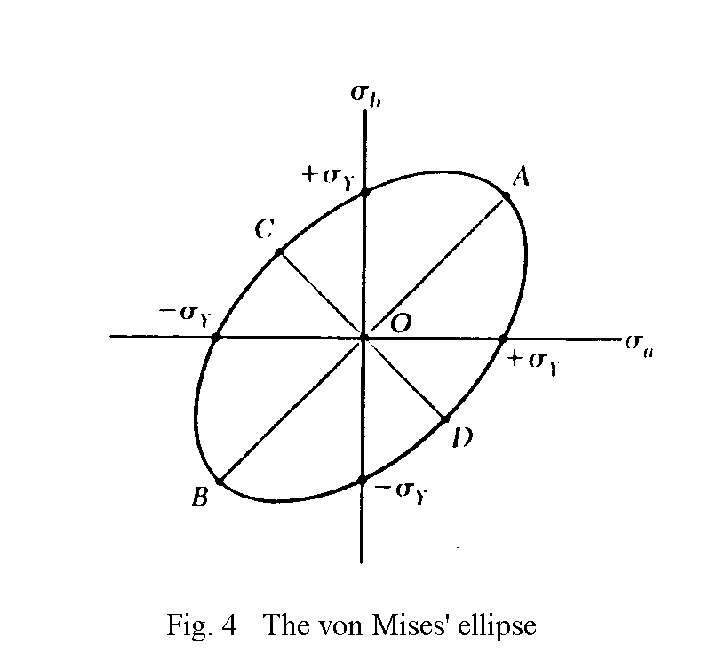

APPARATUS:

Tensile tester, Fixture for performing the shear yield test, polypropylene (pp) strip specimens for shear yield tests, pp dumbbell specimens for tensile yield tests.

PROCEDURE :

- Perform the tensile yield test with the pp dumbbell specimens and evaluate the yield point from the resulting stress-strain curve.

- Mount the fixture on the tensile tester and perform the shear yield test with the pp strip specimens.

- Construct the corresponding Tresca’s hexagon and the von Mises’ ellipse and demonstrate the validity of these yield criteria.

DISCUSSION:
Explain the principle of deriving the two yield criteria (Tresca and von Mises) and their main differences, and how they can be applied in the design of structural components.

PART – 2
ANIMATION STEPS
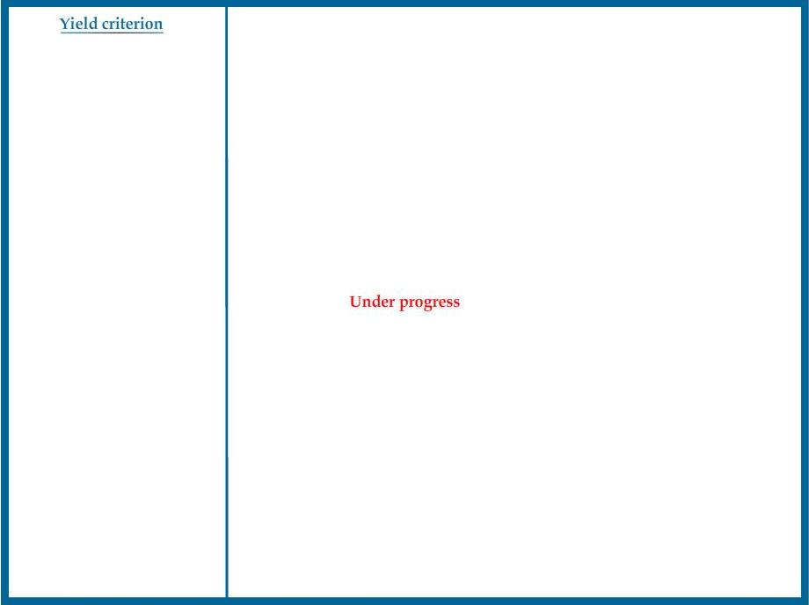

PART – 3
VIRTUAL LAB FRAME

